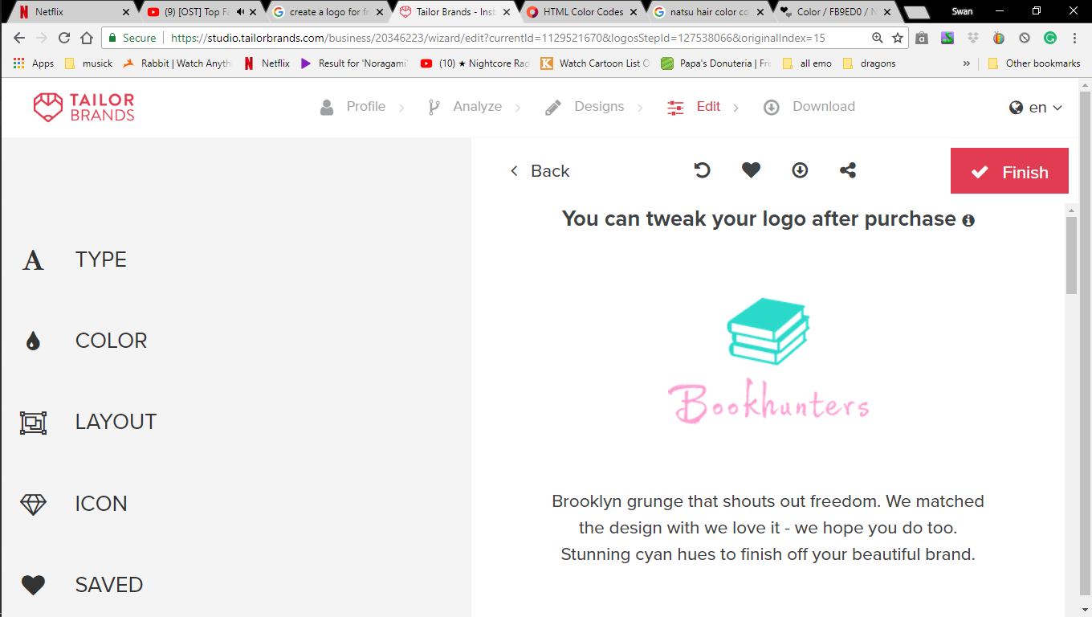

Love simon

“'Simon vs. the Homo sapiens Agenda' by Becky Albertalli is a book about a closeted homosexual high school boy named Simon Spier. He has fallen in love with a mysterious 'Blue' that he sent emails to. One day, Simon was using the school library computer to send an email to Blue and when he was done he turned off the computer without logging off his account. After he left another student, Martin, turned on the computer and found out about Simon's emails. Simon then had to help Martin out by trying to make his best friend Abby fall in love with him. If he didn't do what he was told, Martin would leak the emails to Tumblr and the whole school would find out that Simon was gay. This is obviously blackmail.

I would highly recommend this book to anyone over the age of 13 as it deals with a worldwide spoken topic and uses strong language. It is a comedic, drama, romance novel. If you're also interested, a film about the book came out (pun intended) last May by the name of Love, Simon”

Miss peregrine

“I read the Miss Peregrine's Home for Peculiar Children trilogy by Ransom Riggs. I really liked the plot, which was very unorthodox and is not at all like the average fantasy book ones. Although the three books are quite lengthy, the read was very enjoyable an there wasn't a dull moment. I also noticed how well Riggs developed all of the characters, making the reader fond of every one by the end of the series. My favourite book of the three was definitely Library of Souls, the third and final book, since it is where all the pieces in the puzzle come together. Also, having watched the film as well, I would like to add that the books are by far better!”

Fantastic beast and where to find them screen play

“I love this book, this is the screenplay so it was written like a script and because of that I managed to get a clearer image of the movie when I imagined it in my head. It tells the story bit by bit as expected from the author J.K Rowling. She is great at what she does, and I am glad she does it. Usually when we think of heroes from the school of Hogwarts we think of Gryffindor or sometimes we this of Ravenclaw and a bad house to be in we thing Hufflepuff because they get picked on or are the week ones, Slytherin is the house where, it is most known for its secrets.

The protagonist, Newt, is from Hufflepuff here, Newt shows great care for all the bests alike, does not take notice of others like him. He cared for their wellbeing and nothing else. This shows how far his kind heart takes him, for beast to people to other things even more dangers then you could think of. This shows us more about the house we do not see in the Harry Potter. A new one is coming in 2019 and I think it will be just as good as all of J.K Rowling’s works.”